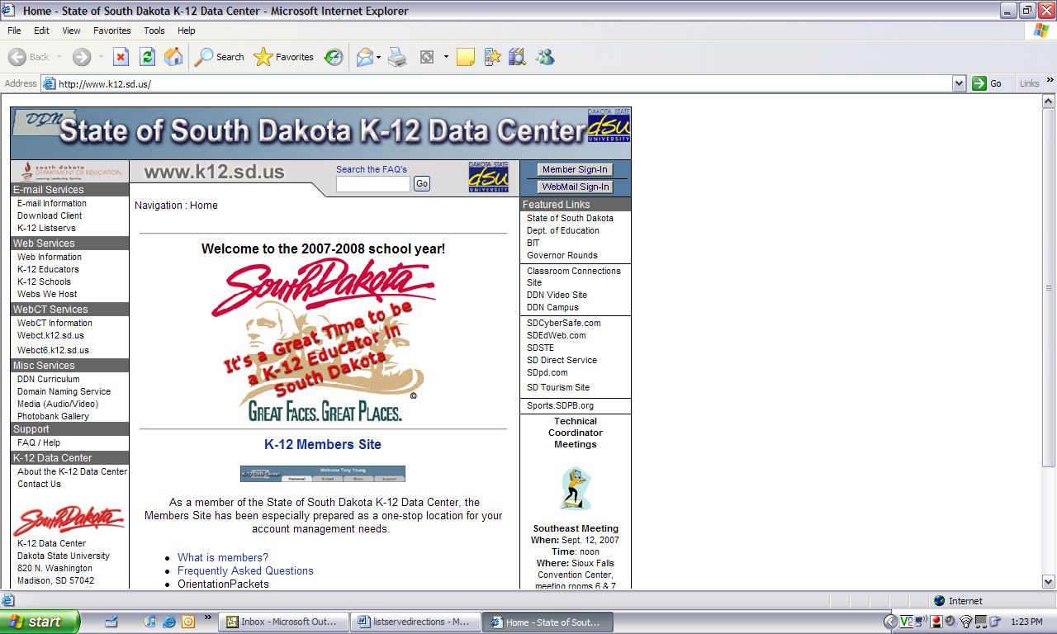

Click on the thumbnail located on the left hand side of the screen under email services called “K-12 Listserves”.

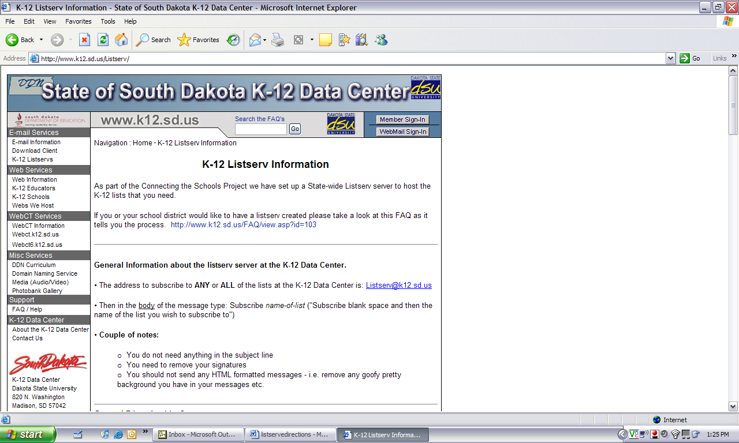

On the bottom of this page you will find a list of all the list serves. This is where you need to select “Elementary Principal List”.
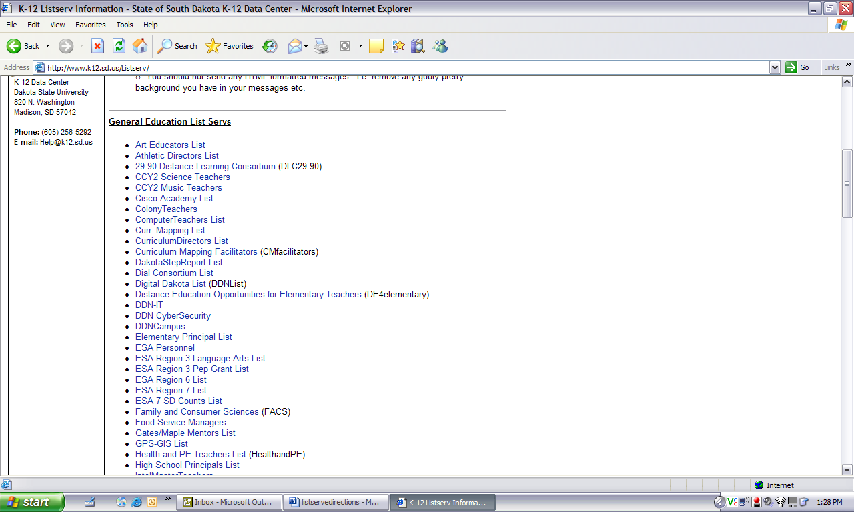

After selecting the Elementary Principal List you will be taken to the subscription page. Follow the instructions on this page to sign up for the listserve.

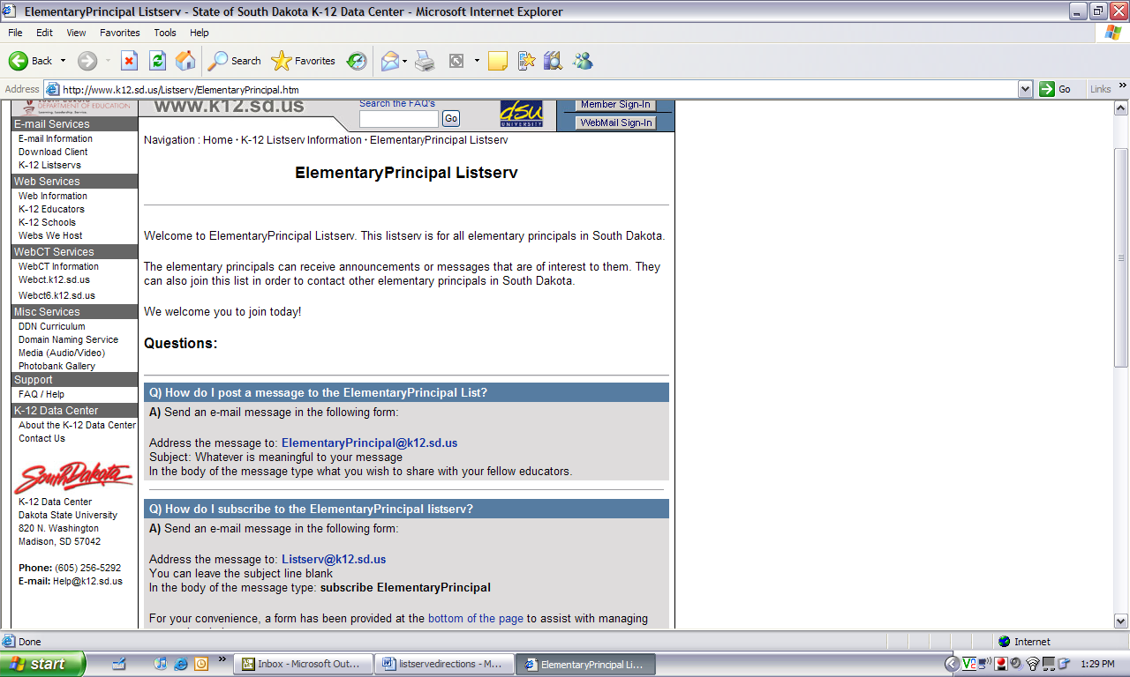
You can fill out this form located on the bottom of the page, but if you don’t get a confirmation email you need to sign up by sending in the email located on the top of the page. It is easier to copy and paste the message that goes in the body of the email, because if it is not typed properly it will not work.

